Predicting Customer Churn
CIS 4930
Fall 2025
Naomi Ajayi

Table of Contents (including page numbers)
- Project description (2)
- Data Exploration and Preprocessing
- 2.1 Target and Predictors (3)
- 2.2 Initial Exploration and Graphs (4-5)
- 2.3 Missing Data and Data Quality (5)
- 2.4 Data Transformation and Encoding (6)
- 2.5 Train Validation Split (6)
- Modeling
- 3.1 Techniques That Can Be Used to Fit the Data (6)
- 3.2 Model formulations (6-7)
- 3.3 Model Specifications (7-8)
- 3.4 Variable Selection Techniques used (8-9)
- Results and Discussion (9)
- Summary and Description (10)

1 Project description
This project uses a telco dataset, which has over 7000 customer records, to forecast churn predictions for a telecom firm. This dataset includes information on services each customer applied for, customer account information, demographics, and customers who left within the last month. Using this allows us to be able to identify whether a customer churned or not with the company.
Customer churn can have a significant negative impact on a business since it can lead to a loss of revenue and hinder the company's growth. For this reason, it is critical for businesses to be able to recognize the variables that contribute to customer churn and reduce the risk of losing money. Our objective is to use the Telco dataset to help develop a prediction model that can recognize these variables, categorize whether or not a customer will churn, and use the findings to provide managerial insight that can be utilized to lessen business loss brought on by churn.

2 Data Exploration and Preprocessing
2.1 Target and Predictors
- Target variable: Churn (“Exited” is the churned account)
- Input variables (predictors):
  - Demographic: Gender, SeniorCitizen, Partner, Dependents.
  - Account & service: Tenure (months), MultipleLines, InternetService,
  - OnlineSecurity, OnlineBackup, TechSupport, StreamingTV, StreamingMovies,
  - DeviceProtection, Contract, PaperlessBilling, PaymentMethod.
  - Billing: MonthlyCharges, TotalCharges.
2.2 Initial Exploration and Graphs
We used a heat map to help visualize and differentiate the least important from the most important features in determining the relationship between coefficients. The numbers indicate how strongly it is related to the coefficient between -1 and 1. If the value is positive and closer to 1, that indicates that it is a positive correlation and there is a high chance of churn. Likewise, suppose the value is closer to -1. In that case, this will indicate that the chances of churn are lower/ not likely, and if the value is close to 0, that indicates that the relationship to churn is very weak or there is no linear relationship between the feature and churn. Regarding the color scale, if it is a reddish color (moving towards 1), that suggests that there is a stronger positive correlation. Blue (moving towards -1) means there is a negative correlation, and white/ light colors (around 0) mean that the relationship is weak. The results indicate that Contract_Month-to-month (around 0.40) has one of the strongest positive correlations, meaning customers on a month-to-month contract are significantly more likely to churn. Tenure (around -0.42), years with the service, has the strongest negative correlation and is less likely to churn. OnlineSecurity_No (around 0.34), TechSupport_No (around 0.34), and InternetService_Fiber optic (around 0.31) have a moderate positive correlation with churn. Customers without online security or technical support, or customers with fiber optic internet service, tend to churn more. TotalCharges (around -0.28) and Dependents_Yes (around -0.24) are negatively correlated, so this indicates that customers with higher total charges or those with dependents are less likely to churn. Lastly, MonthlyCharges (around 0.14) and SeniorCitizen (around 0.15) have a weaker positive correlation, meaning higher monthly charges and being a senior citizen slightly increase the likelihood of churn.

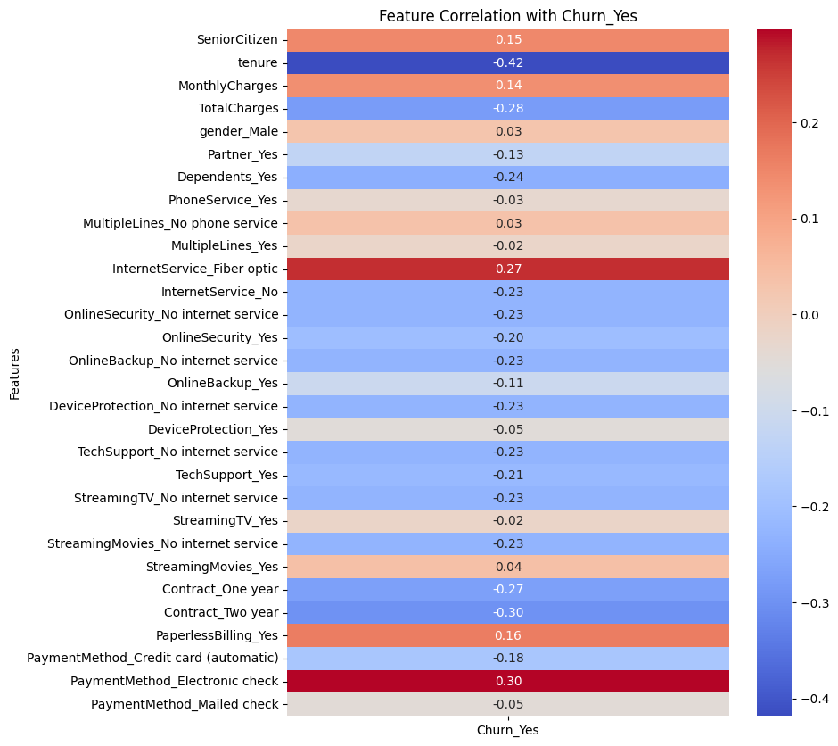
Figure 2.2.1 Heat Map
2.3 Missing Data and Data Quality
In order to clean the data, we removed the CustomerId column due to it being an identifier and not holding any value when predicting Churn. The TotalCharges column contained some empty cells, which made it a string variable, so in order to fix that, we converted the column to a numeric format and replaced any empty cells with NaN, which were later dropped to ensure that all entries in that column are valid. For the Decision Tree, we also pruned rows in Churn with a NaN value to ensure that they were dropped. After performing the NaN clean up and dropping the CustomerId column, we checked to ensure that there were no more missing values and no duplicate rows to make sure the data quality remains good before training the models.
2.3 Redundant Data/ Correlation
The redundant data that was in the excel file was CustomerID because it's an identifier. The correlation data was TotalChargers and MonthlyCharge because it accumulates each other.
2.4 Data Transformation and Encoding
We dropped ‘CustomerID’ due to it being an identifier and holding no predictive value. For the column ‘TotalCharges’ it had spaces, characters, and missing values which made the model read it as a string so we converted it to a numeric and used NaN to fill the missing values and then dropped it so the model can read it easily. Lastly, we dropped any missing values and duplicates from other columns to ensure that the dataset is completely cleaned.
2.5 Train Validation Split
- The training set was 60% of the data, and the testing set was 40% of the data.
3 Modeling
3.1 Techniques That Can Be Used to Fit the Data
We used logistic regression, decision tree, and a KNN model to fit the data. We used these models to classify whether or not a customer would churn. Logistic regression was chosen because of the simple classification nature of the model and how it is widely used for churn predictions. A decision tree was chosen for similar reasons, especially since it shows a detailed reasoning for the classification. Finally, a KNN model was chosen due to its classification method and ability to capture complex interactions between variables. The model would work well with our data, since KNN works by classifying the outcome based on similar customer behavior of other variables
3.2 Model formulations
We formulated the model with all of our variables in mind. We chose “churn” as our dependent/output variable, and dropped the “customerID” column since it is irrelevant to the output variable. We made many assumptions about the data to make it easier to find a solution to our original business problem. We assumed that if customers were labeled as “Exited”, their accounts had churned. We also looked at the 19 other factors in the data set to assess what affected a customer’s likelihood to churn. In this initial process, we classified which variables were categorical and which were continuous. We applied these formulations across all of our models, with churn being the dependent variable and using the models to choose the variables with the strongest effect on the dependent variable as a predictor.
For the Logistic Regression, we formulated the model by separating the data into a training and testing set, which prevents overfitting and evaluates the performance. We also included hyperparameter tuning with randomized search, which helps find the best possible solver, penalty, and regularization strength.
In the Decision Tree, we formulated the model as a recursive binary split. This outputs a set of decision rules and groups customers based on similar churn behavior. It repeatedly partitions the data into two regions based on the best possible split, and the process repeats until a stopping criterion is met.
For K-Nearest Neighbors, we formulated the predicted class and the distance metric. For the predicted class, we assigned the majority vote of k nearest neighbors; for the distance metric, we assigned the default Euclidean distance. K was optimized from 1 - 15, and we standardized the features using StandardScaler.

3.3 Model Specifications
For the Logistic Model, predictor variables of all numerical and encoded categorical features were put into X_train, with the target variable being churn. The following hyperparameters also included solver, penalty, C, and max iterations.
For the Decision Tree, we provided a before and after pruning classification report and confusion matrix. We used the results from these to show us how pruning is necessary to get the most accurate results and how overfitting affected the prediction on churn. A variety of specifications were used to control the complexity and prevent overfitting during the pruning of the model. We implemented “max_depth” and “min_samples_leaf”. For maximum depth, it limits the tree to a maximum of five layers of splits, thus limiting the number of splits and reducing complexity. Minimum samples per leaf ensure each node has enough observations. We set the minimum to thirty samples, which in turn helps with preventing overfitting.
In the K-Nearest Neighbors model, we experimented with different specifications and landed on these as our final. We tested k values 1-15 to find the best version. We did this with a for loop, with the loop assigning a previously defined list the accuracy score of the tested k at the end of each run. We standardized the features of the model to improve model performance. If the features are not standardized, then certain features with outlier measurements may skew the predictions of the model. This process allows all features to contribute equally to the distance calculation of the k.
Our data was split 60/40 for training and validation. We made sure to stratify our data to preserve class proportions of the original data set. We selected the best k based on validation accuracy. This allowed us to choose the best k possible, based on the training and the validation data.
3.4 Variable Selection Techniques used
In all three models, one-hot encoding was used to convert categorical variables into binary variables. This helped us ensure that these categorical data points were converted to numbers. Random Search was also used to control model sparsity in the logistic regression model.
4 Results and Discussion
The logistic model resulted in an accuracy of 78.82% with the precision of 0 (no churn) being 0.83 and 1 (churn) being 0.62. The model is predicting high true negatives, which is good for predicting loyal customers. It shows a higher number of false negatives than false positives, which indicates that it struggles to predict customers who actually churn. This model is useful for identifying stable customers correctly with its high precision. However, the moderate false positives and false negatives can be an issue because the business might waste more resources on retaining customers who were already staying, or they might lose customers by failing to identify those at risk for churn.
Confusion Matrix:
[[918 115]
[183 191]]
Classification Report:
precision recall f1-score support

0 0.83 0.89 0.86 1033
1 0.62 0.51 0.56 374

accuracy 0.79 1407
macro avg 0.73 0.70 0.71 1407
weighted avg 0.78 0.79 0.78 1407

After pruning the decision tree, the classification report resulted in a precision of 0.83 for 0 (no churn) and 0.61 for 1 (churn). The model is predicting high true negatives, which is a good sign because most customers do not churn. It also shows a higher number of false negatives than false positives, which indicates that it struggles to predict customers who churn. This error can be costly because the company loses customers that they could have identified and used more resources to prevent them from leaving. The false positive causes companies to waste resources on trying to retain customers who are already loyal to the company.
--- Confusion Matrix (Pruned Model) ---
[[457 60]
[ 92 95]]
--- Classification Report (Pruned Model) ---
precision recall f1-score support

0 0.83 0.88 0.86 517
1 0.61 0.51 0.56 187
accuracy 0.78 704
macro avg 0.72 0.70 0.71 704
weighted avg 0.77 0.78 0.78 704

The KNN model had an overall accuracy of 82.01%. This was the highest overall accuracy out of our three models. Its precision of Churn (1) is 67.2% and No Churn (0) is 87.0%. Like the other models, this model can predict the number of True Negatives, customers who will not churn, fairly well. Although we are not able to identify a very high number of customers who may churn with this model, we are able to identify almost 70%, which is an extremely useful piece of information.
precision recall f1-score support
0 0.870 0.888 0.879 2065
1 0.672 0.632 0.652 748
accuracy 0.820 2813
macro avg 0.771 0.760 0.765 2813
weighted avg 0.817 0.820 0.818 2813

5 Summary
Our models were better at predicting customers who would churn due to the precision score averaging above 60% across all three models. The KNN model performed the best with a score of 0.702 for ‘Churn’, meaning that when the model was predicting customer churn, it was correct 67.19% of the time. The next-best performing model scored a 0.62 for ‘Churn’, and the third-best performing model scored a 0.61 for ‘Churn’. Using this information, we suggest that the company use a combination of models to get the best predictability on churn because using only one model is not sufficient. We learned how complex it can be for companies to maintain customer retention and how multiple resources are needed to help maintain customer loyalty and prevent customer churn.

